Project Performance Test

Date | 1 July 2026
Team ID | PNT2022TMIDxxxxxx
Project Name | Emotion Detection & Learning Support Engine
Maximum Marks

Model Performance Testing:
Project team shall fill the following information in model performance testing template.
S.No. | Parameter | Screenshot / Values
 | Data Rendered | Input String Corpus: Unstructured textual queries representing student coding/academic issues.  Model Outputs: High-dimensional dense arrays representing target emotion categories (Confused, Frustrated, Excited, Bored, Neutral).  Generative Content: Explanatory text strings containing empathetic validations and educational hints.
 | Data Preprocessing | Text Cleansing: Standard tokenization, lowercasing, and punctuation filtering via regex string operations.  BERT Tokenization: Sub-word WordPiece encoding padded or truncated to a fixed max_length = 128 sequence window.  BiLSTM Sequence Encoding: Numerical index mapping paired with zero-padding to standardize variable-length input tokens.
3. | Utilization of Filters | Dynamic State Toggles: Frontend dashboard view switches to alternate the UI viewport between the Learner Self-Reflection Portal and the TA Batch Message Triage Panel.  Confidence Threshold Gate: Filters out predicted emotions that fall below a minimum probability limit (e.g., confidence < 0.40) to prevent noisy validation outputs.
4. | Calculation fields Used | Softmax / Sigmoid Probability Array: Calculations evaluating Multi-Label logit tensors into readable percentage scales ($0.0$ to $1.0$).  Delta Variance Calculation: Computed arithmetic variation ($\Delta$) tracking the accuracy delta between the BiLSTM and BERT prediction arrays.  Latency Profiling: Math metric tracking inference execution runtime parameters (end_time - start_time) to enforce performance constraints.
5. | Dashboard design | No of Visualizations / Graphs - 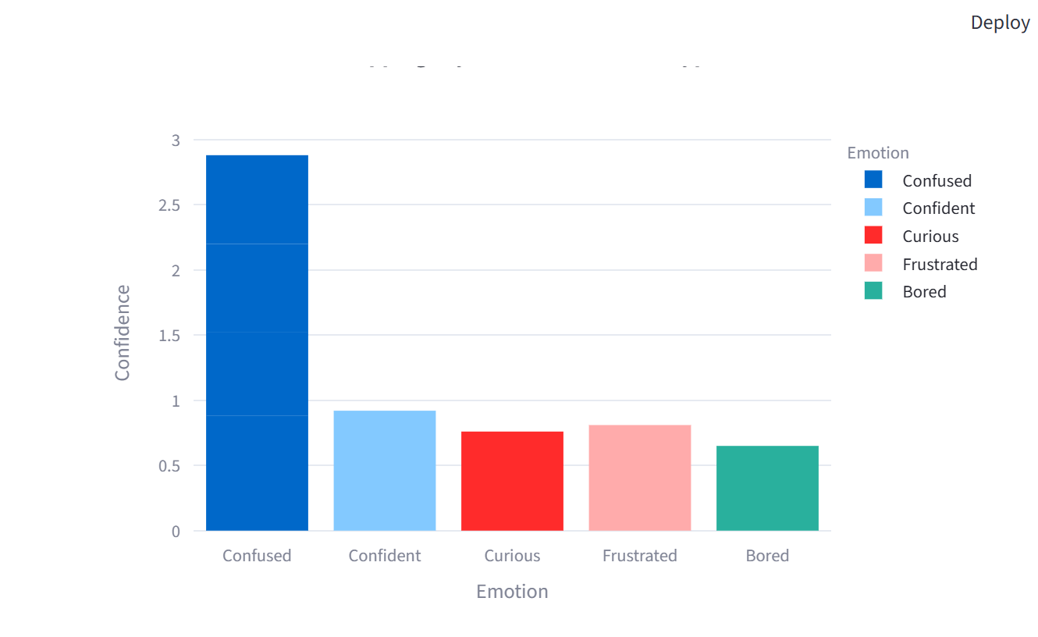  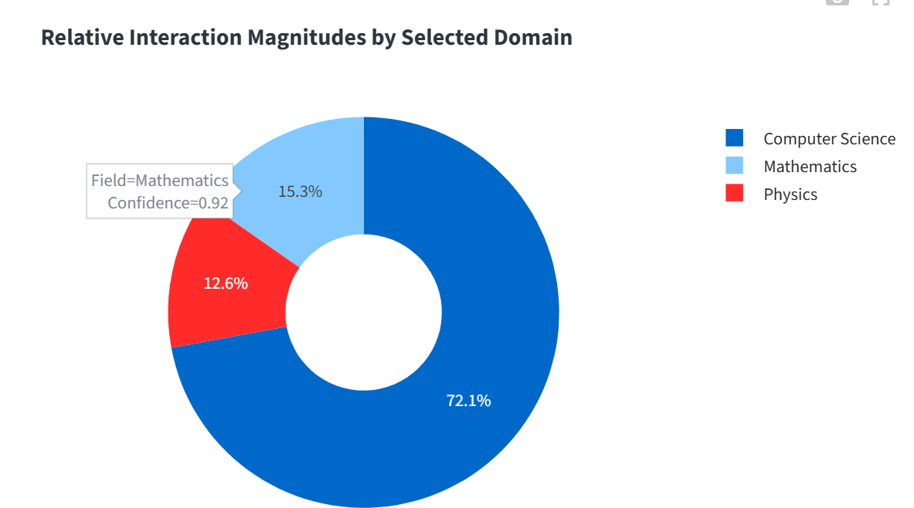
6 | Story Design | No of Visualizations / Graphs -